**Name: Sarthak Shandilya**

**Assignment 5 (Ticket Booking System)**

**Submitted to: Karthika**

**Hexaware Technologies**

**Package maintenance according to assignment**

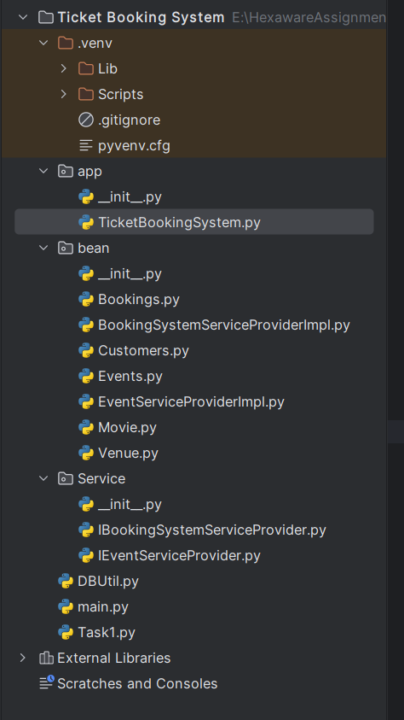

This program starts when we run **Ticket Booking System file** in **app package**

This file asks user input to type few commands according to what stated in assignment.

Commands are:

1. create_event
2. get_event_details
3. get_available_seats
4. book_tickets
5. cancel_tickets
6. exit

**Ticket Booking System** file in **app package**

Program starts by running this file.

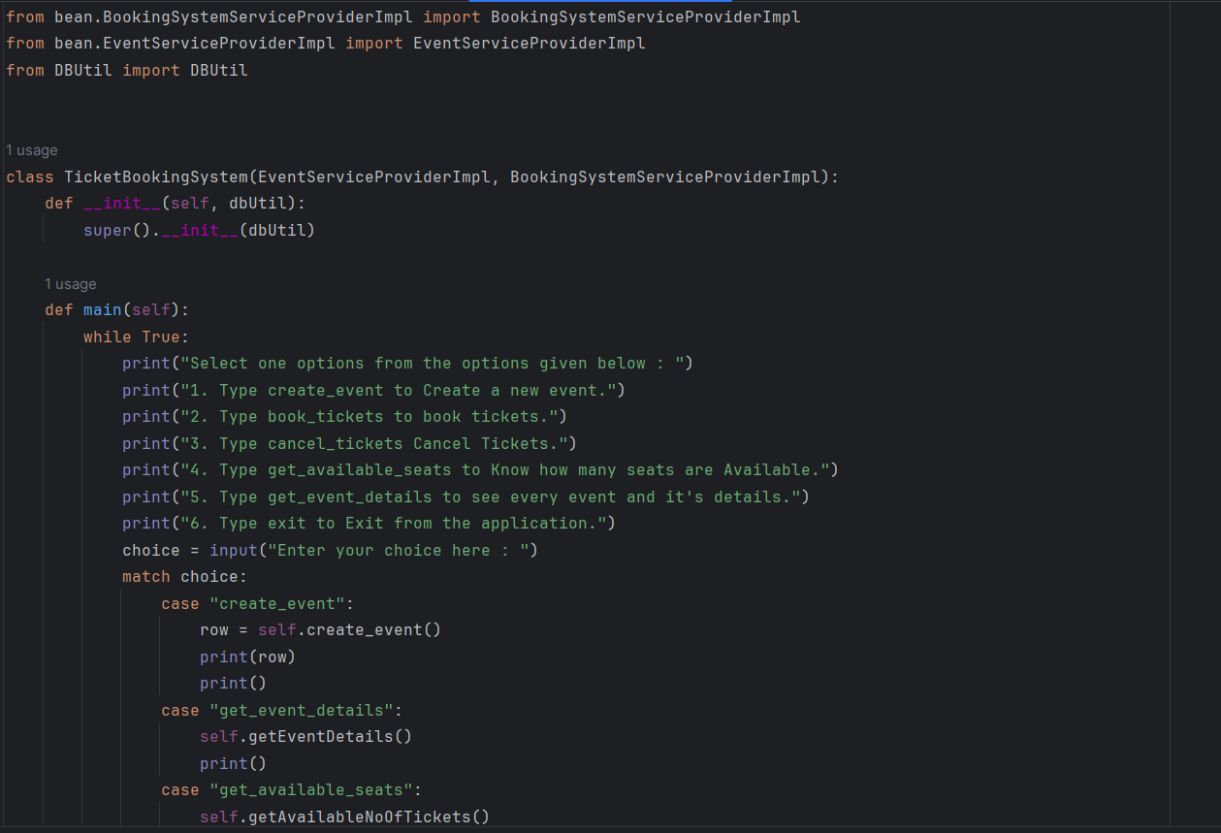

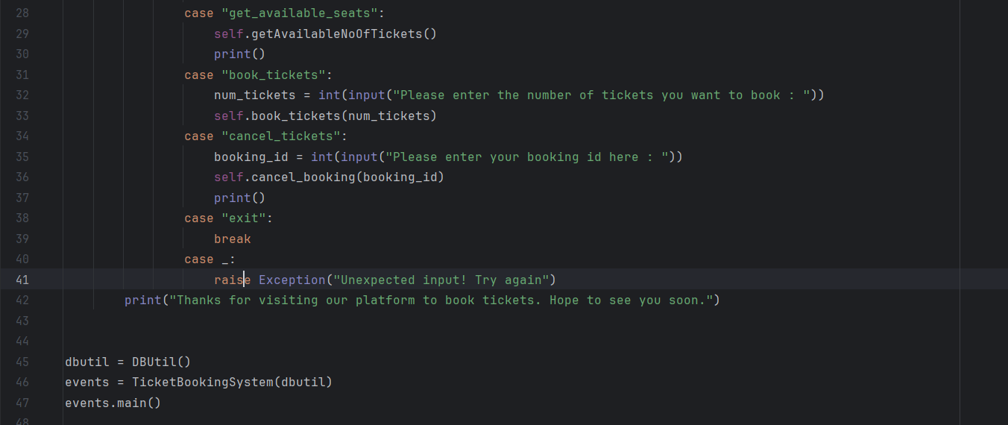

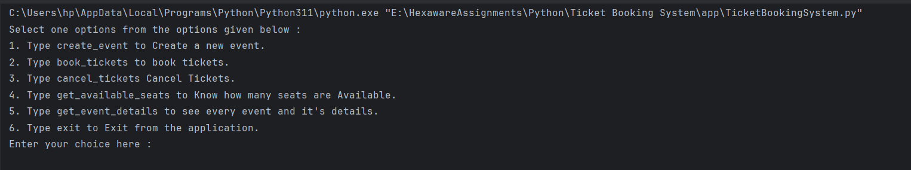



**1. Create_event**

**Code:**

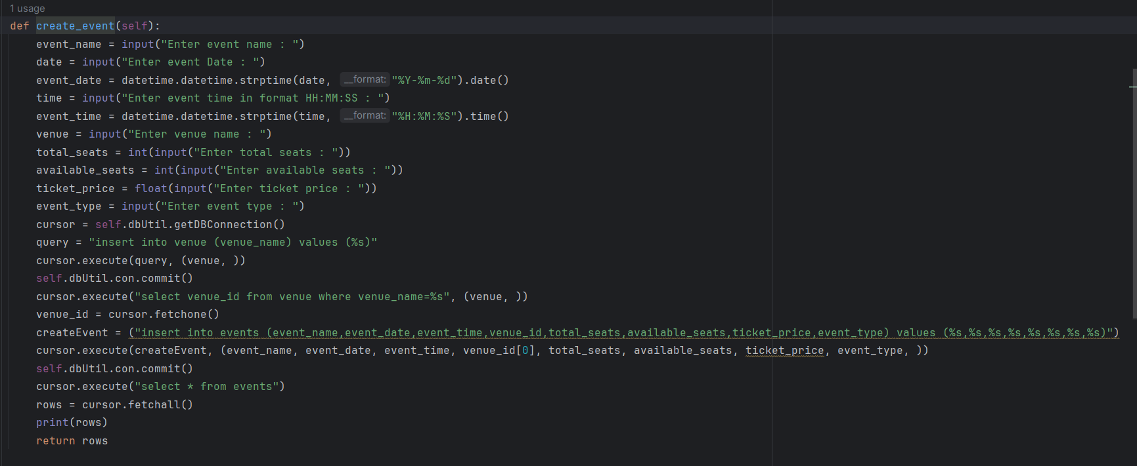

**Output:**

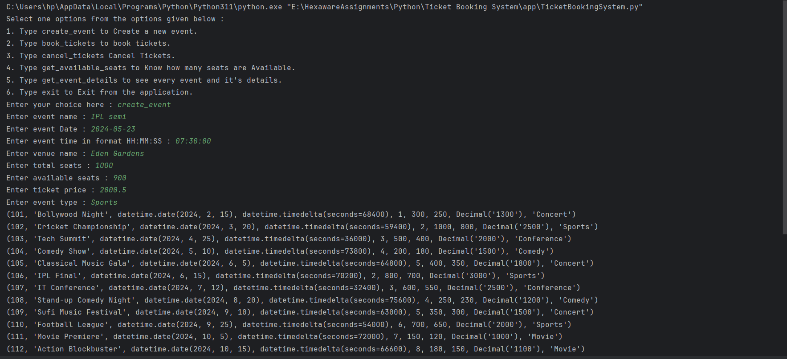

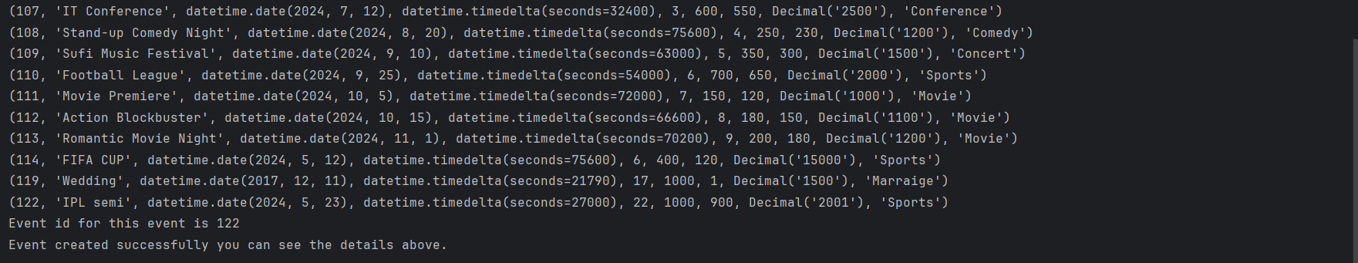

**Updates in database:**

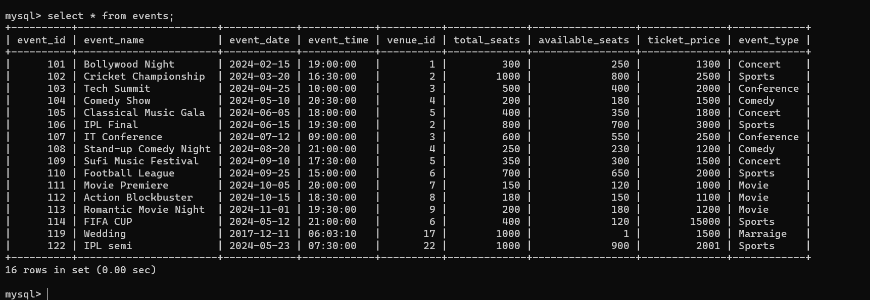

1. **Book_tickets**

**Code:**

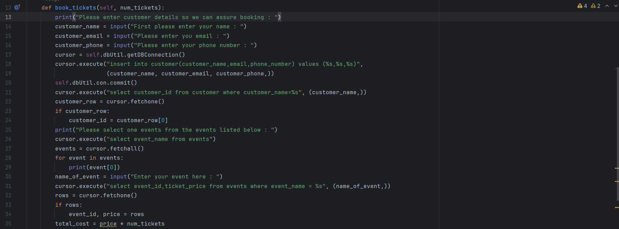

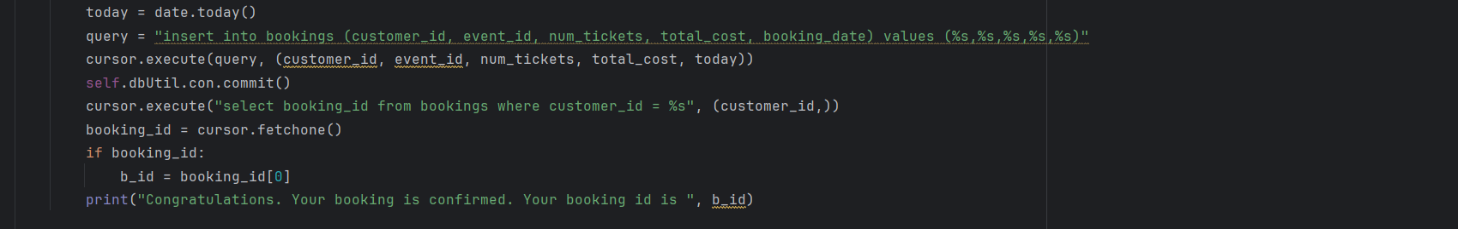

**Output:**

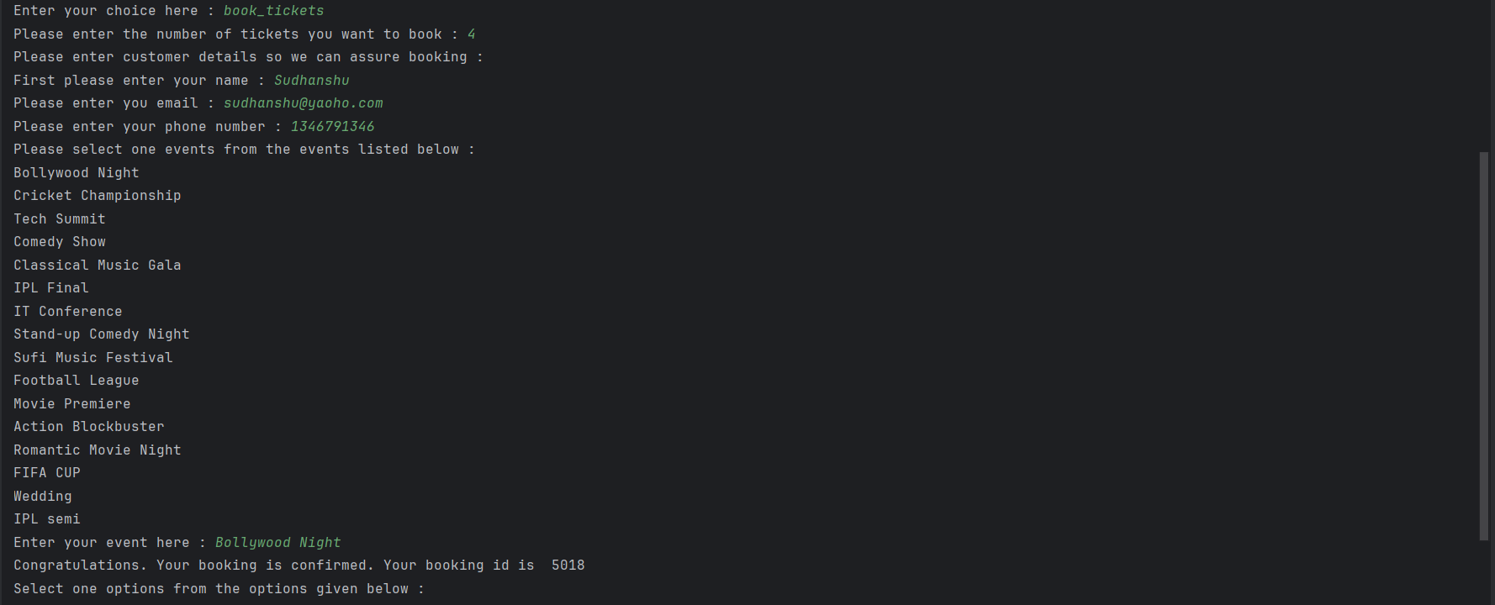

**Updates in database:**

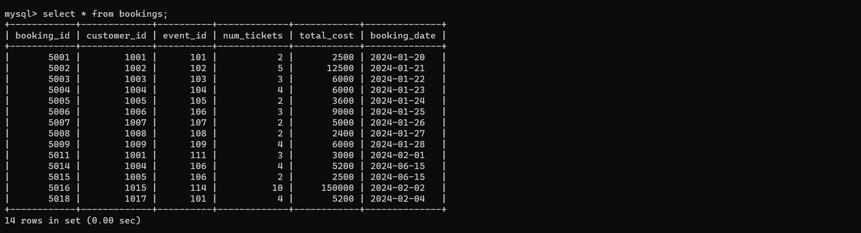

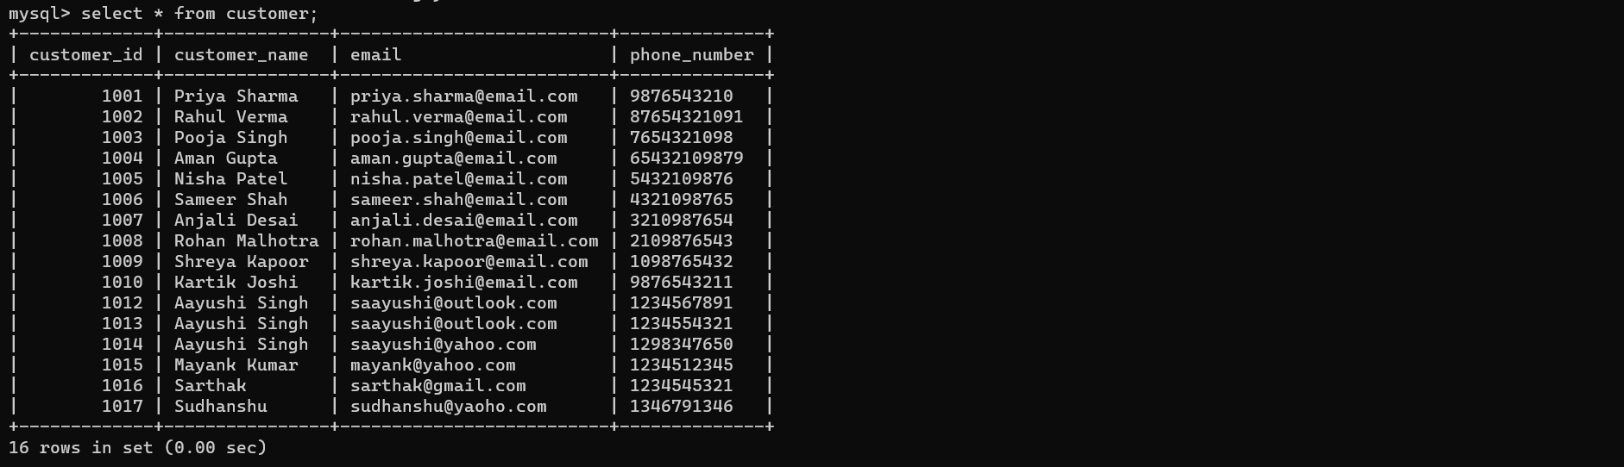

1. **Cancel_bookings**

**Code:**

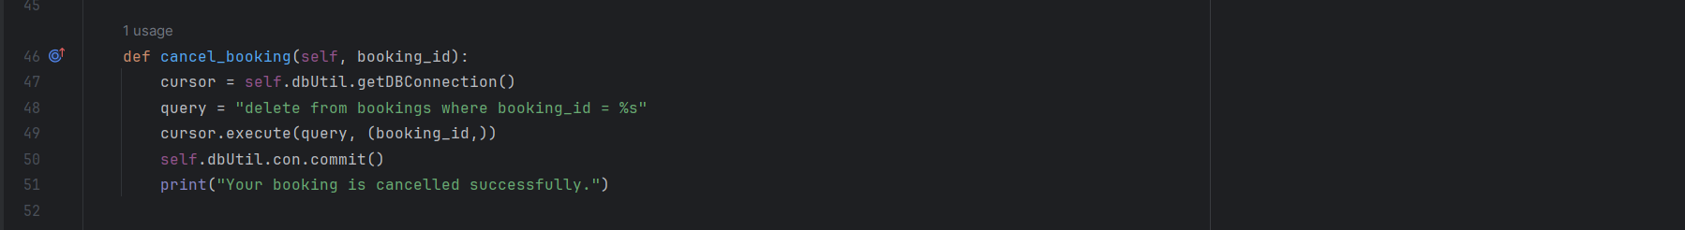

**Output:**

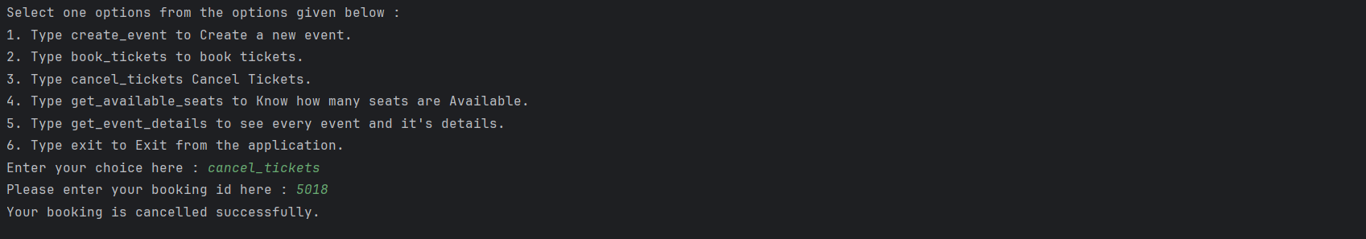

**Updates in database:**

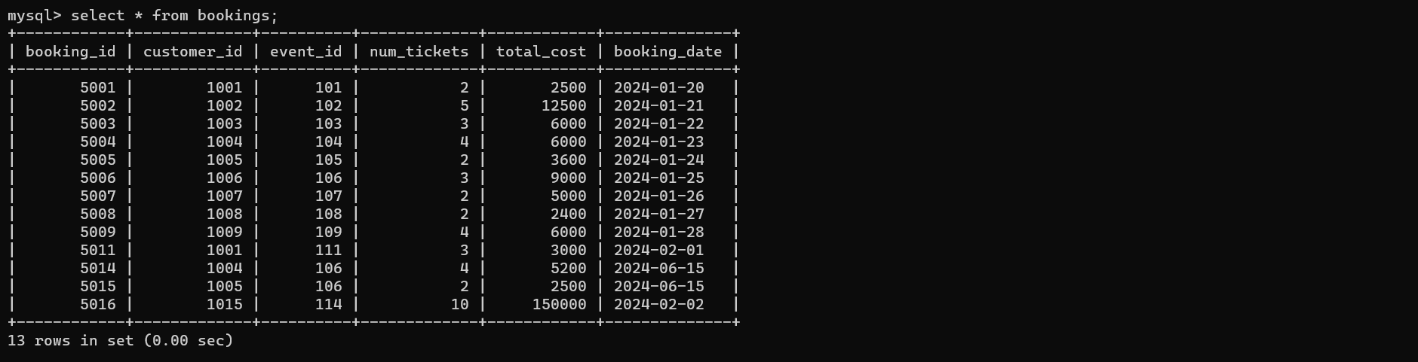

1. **Get_available_seats**

**Code:**

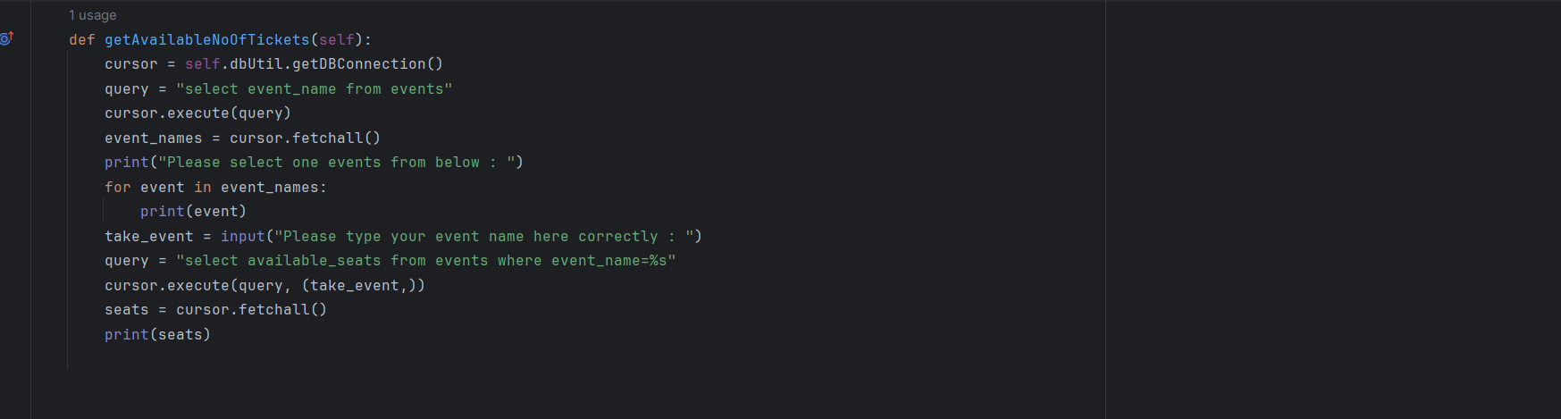

**Output:**

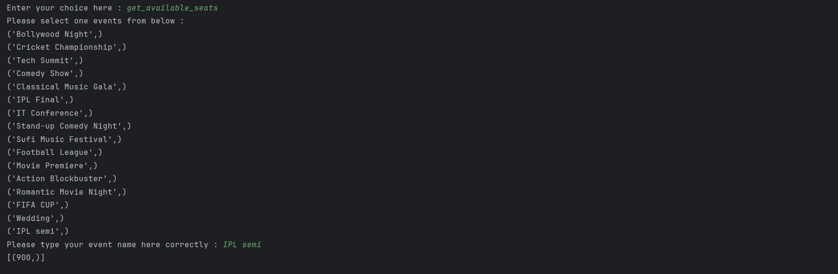

1. **Get_event_details**

**Code:**

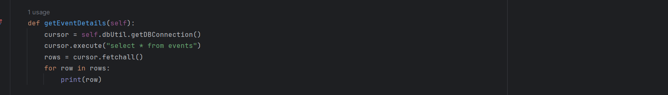

**Output:**

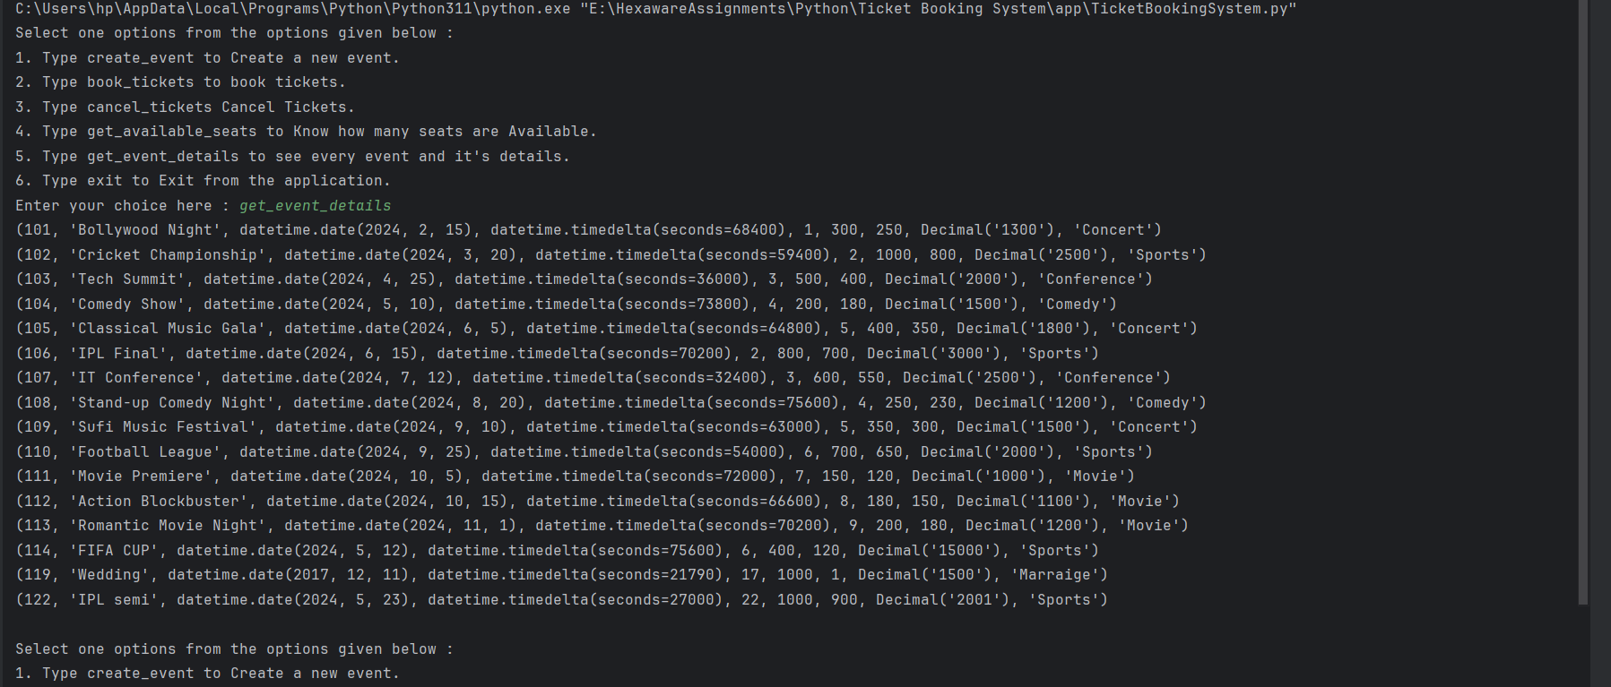

**Customers class:**

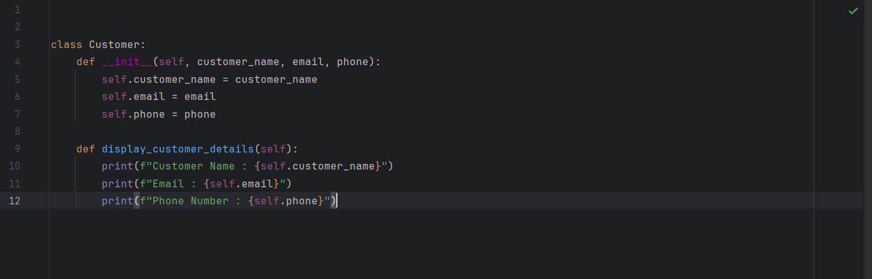

**Events class:**

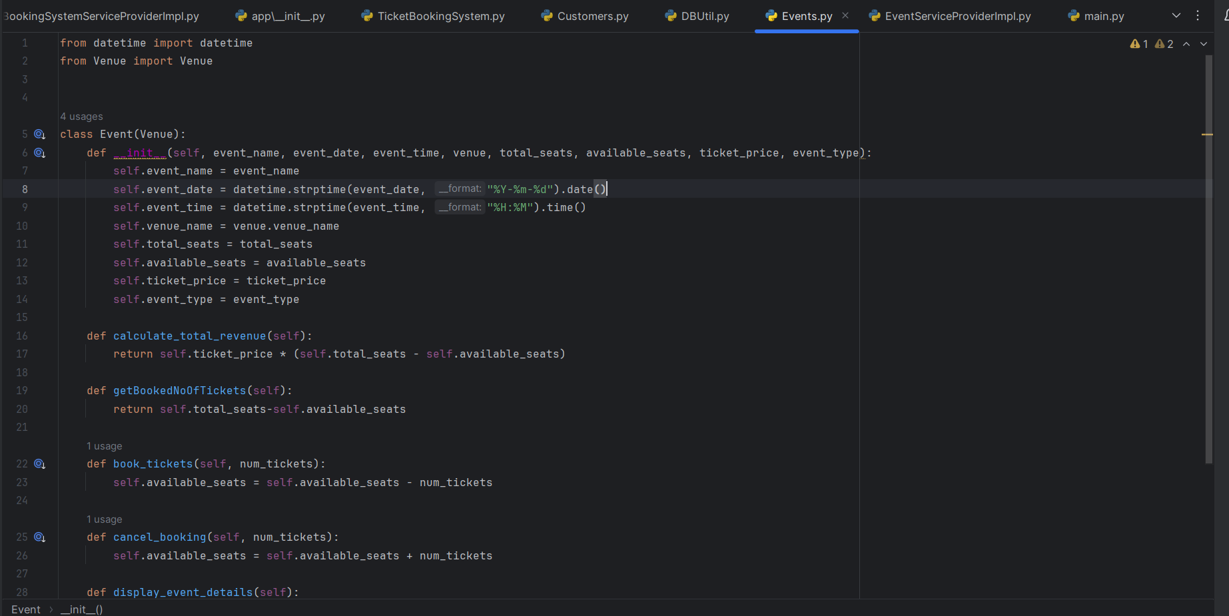

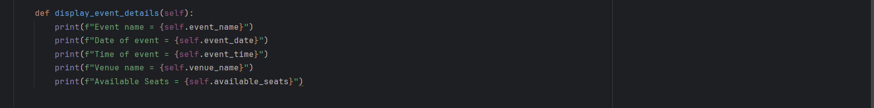

**Movie class:**

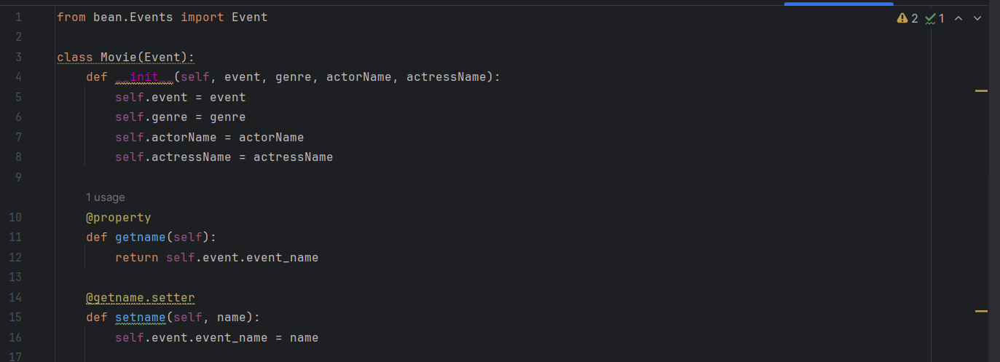

**Booking class:**

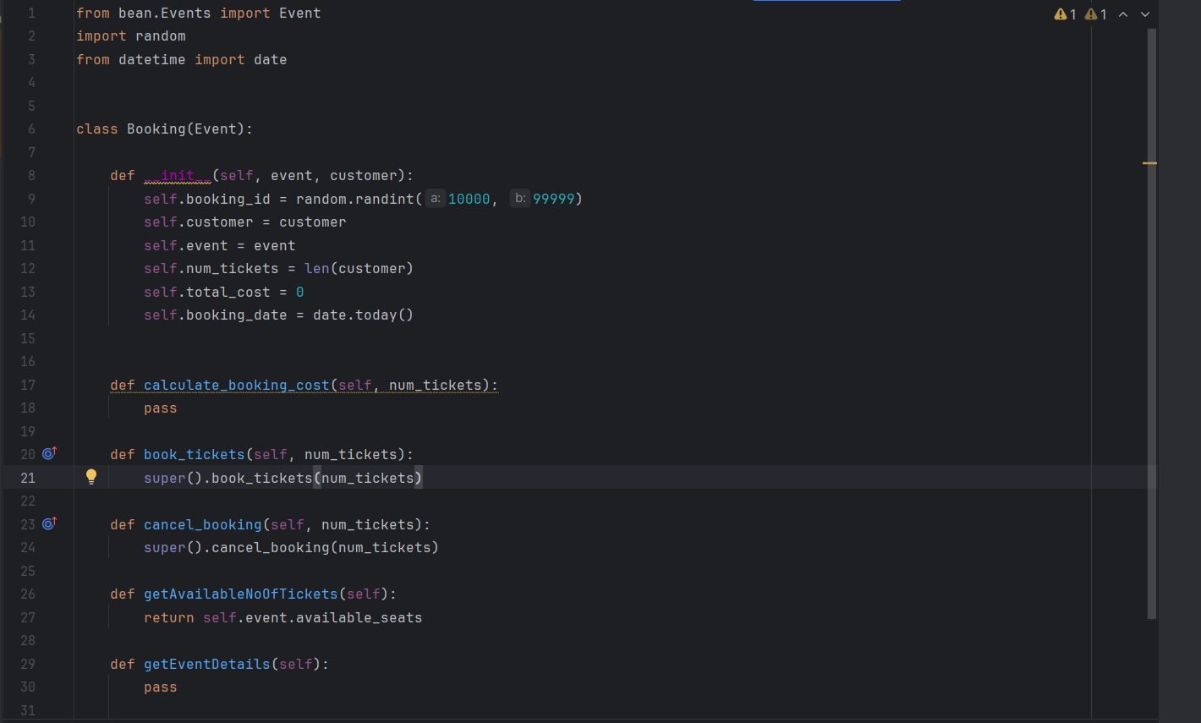

**Venue class:**

